Deployment instructions:

1. Unzip the folder.
2. Now in the terminal/ command prompt, get into the Seelan

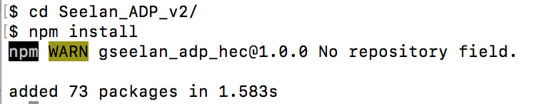

1. Copy the CSV dump into the folder file-csv

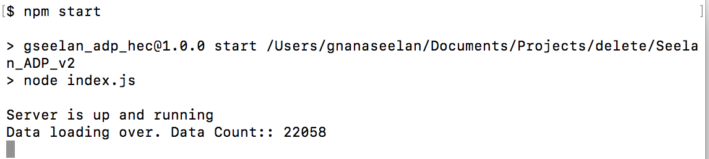

1. Now access <http://localhost:3000/>. You should be able to see the app.

